**CS 207: Applied Database Practicum**

**In-Class Activity 7: Introduction to Triggers, 24th September, 2018**

In this activity, you will be working in Mysql.

For this Activity, load the database from the dump file (trigger.sql) given in moodle. The database name is **activity6.** The database contains 3 tables:

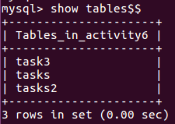

Q1. The trigger will be created for the table **tasks.** (The table schema is displayed below)

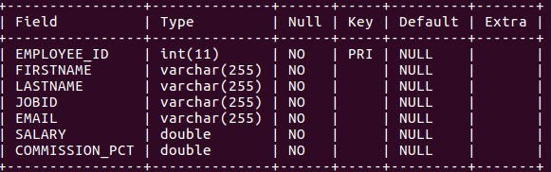

Create a trigger that removes the whitespaces from the column **FIRSTNAME**, **LASTNAME** and changes the **JOBID** value to uppercase when a new record is inserted. [HINT: use Mysql Functions like TRIM].

e.g. **if the following values are inserted into tasks**:



**The output should be something similar to the image below**

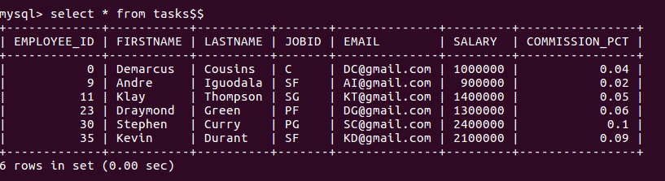

The spaces have been removed from the **FIRSTNAME**, **LASTNAME** and the **JOBID** is converted form ‘**sf**’ to “**SF**”.

Q2. For this question the trigger will be created for the table **task3.** (The table schema is displayed below)

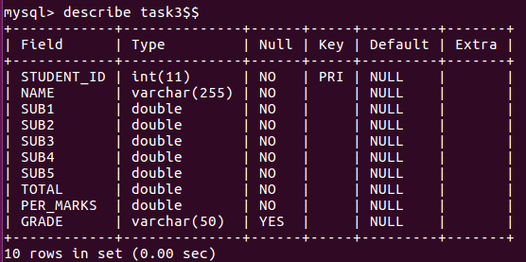

**The table contains only zero values in the beginning as shown in the image below:**

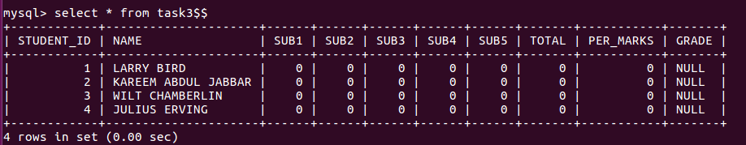

Create a trigger such that when we update the marks of a student for each subject (SUB1, SUB2, SUB3, SUB4, SUB5) in the table **task3**, the trigger should automatically calculate the **Total Marks, Percentage of Marks,** and Gradeof the student and update it in the table **task3**. **The calculations are given below:**

**Total Marks (will be stored in TOTAL column):** TOTAL = SUB1 + SUB2 + SUB3 + SUB4 + SUB5

**Percentage of Marks (will be stored in PER_MARKS column)** : PER_MARKS = (TOTAL)/5  
**Grade (will be stored GRADE column)** :

**If PER_MARKS>=90 -> 'EXCELLENT'**

**If PER_MARKS>=75 AND PER_MARKS<90 -> 'VERY GOOD'**

**If PER_MARKS>=60 AND PER_MARKS<75 -> 'GOOD'**

**If PER_MARKS>=40 AND PER_MARKS<60 -> 'AVERAGE'**

**If PER_MARKS<40-> 'NOT PROMOTED'**

**When we update the marks of a student the output should be similar to the image below:**

